4.7 Notes Write Quadratic Equations - Given the Roots and a Point

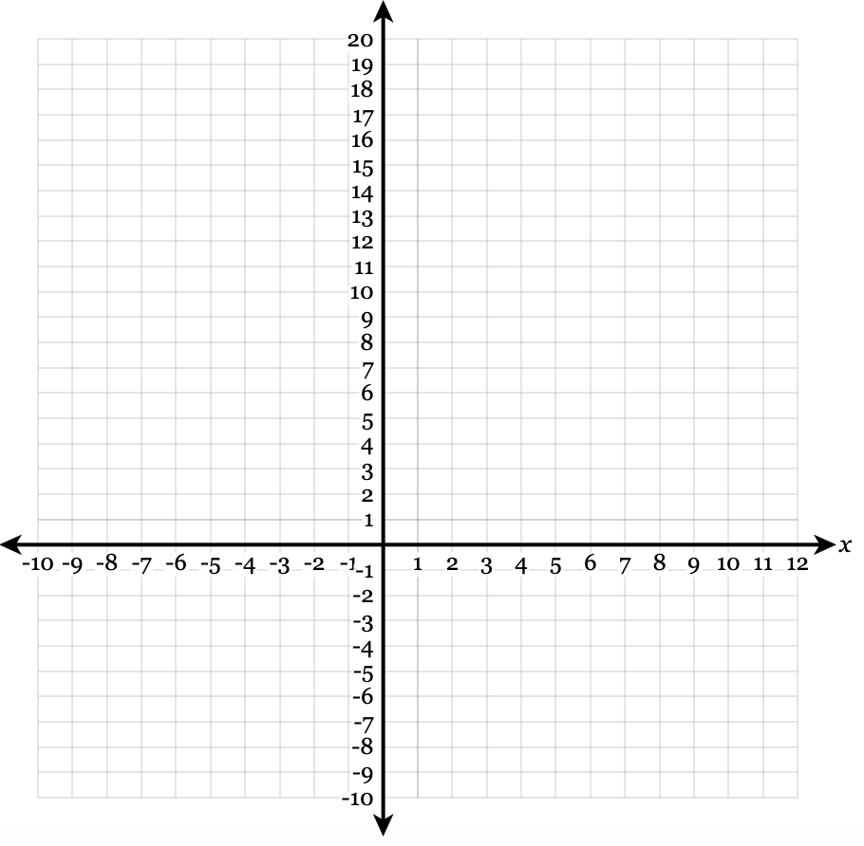
y = a(x – p)(x – q) Write each quadratic equation in standard form: y = ax² + bx + c.
- Roots: -3, 5 Point: (3, 18)

- Roots: $\sqrt{6}, -\sqrt{6}$ Point: (4, 2)
